Initial Table of Level 1:

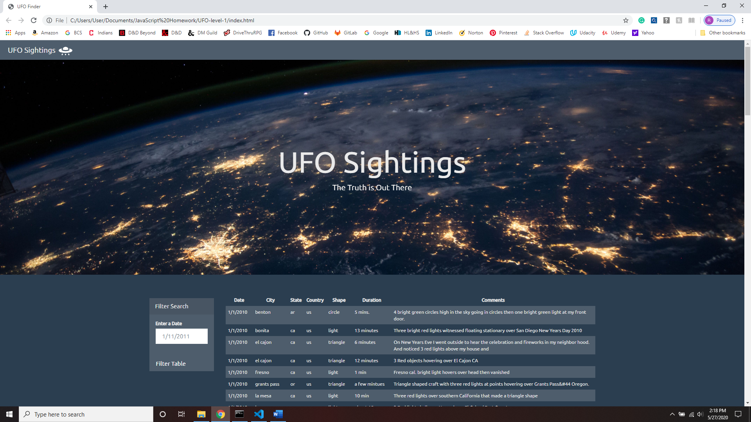

Level 1 search for sightings on 1/3/2010.

